**Diary for session 3**

**Territorial Acquisition Game by Reece Taylor, Steve (Yap Hou Yuen) and Connor Winspur**

What was the game?

The game that me and my team designed was a tile-based strategy game. The game I played on a 10 x 10 virtual board (on a computer). 10 x 10 is the default size of the board for the 4-player free for all mode however there are different modes such as 2vs2 and 1vs1 which have smaller boards due to their smaller player count. The reason for the smaller boards on lower player count games is because it will take more moves to reach the opponent and the game would take longer. The game is intended to take around 30 minutes per game (30 moves per player). Players have a capital which provides them with more units after every turn once this capital is destroyed the player will no longer receive units. The objective of the game is to destroy the oppositions capital and then eliminate all their units.

The gameplay:

Players start with three units that can be placed onto tiles that are adjacent to their other piece or capital. For every 3 tiles the player holds they will obtain an extra unit per turn as well as two units from their capital. The win conditions of the game are either the player that has the last capital wins, or if the turn counter is reached and multiple players still have their capital, whoever has the most tiles wins.

Material required to make the game:

The game is intended to be virtual and played online so no physical material is needed to make the game, other than a computer and the hardware associated (mouse and keyboard). Software will be needed such as operating systems and game development software such as unity. Software for designing the board and board pieces will also be needed such as AutoDesk Maya.

The board:

The image in figure 1 shows a brief design of what the board would look like at the beginning of the game. In each corner is a coloured cell with a crown within them as seen at A. The crown signifies the capital for each team and the colour signifies the team. The image shows there are 4 teams. B shows the tiles that can be conquered by any team.

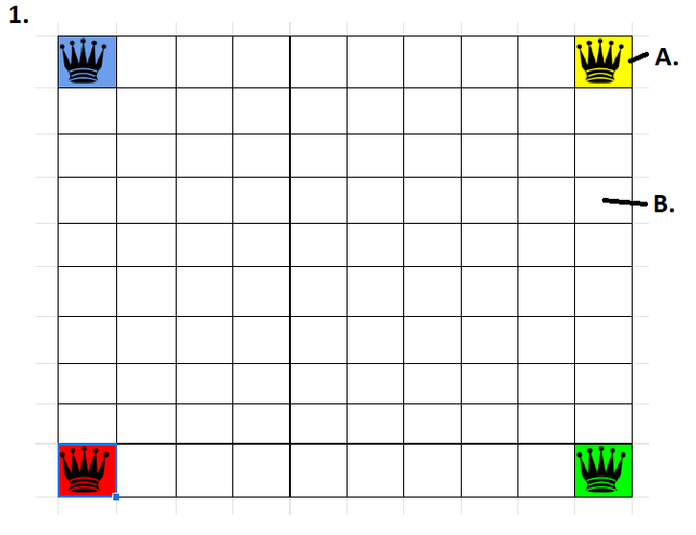

Play testing:

We decided that due to our limitation for time and current circumstances due to corona virus, it was best for our playtesting to be carried out internally. When play testing we found a few improvements that could be made to the game. The main improvement was a calculator for how many units someone should receive after taking their turn. There was confusion between the team about the rules regarding these units as we were unsure how many units each person should receive.

Figure 2 shows our play testing. “A.” shows yellow teams’ capital. “B.” Shows Green team’s units on a cell, as shown green team currently has 2 units on that cell.

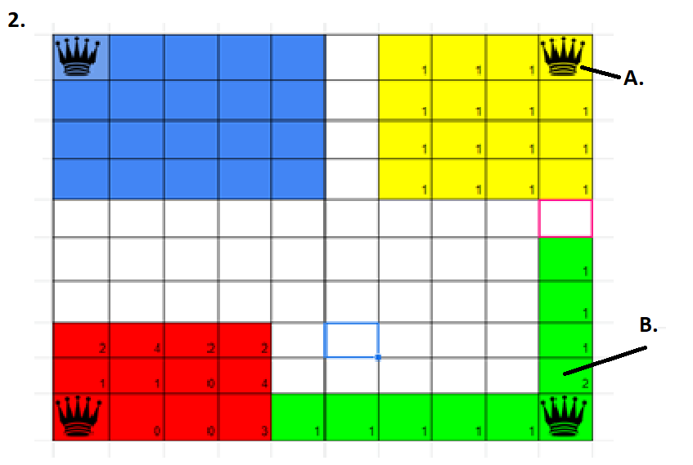

Teamwork:  
Working with my team I found that at the start we faced some issues regarding communication. We were discussing ideas and although we did have different ideas, we were able to combine these ideas into our game. Confusion occurred when we had different thoughts of what each idea was, for example how many units were obtained per turn raised confusion as some people believed the rule meant you gained a piece per tile where as others thought it was a set amount from the capital. After further communicating all confusion was resolved.